# Introduction

The Open Playback Recorder is an open-source device that can record three lists of voice messages that its user can playback via the trigger of an accessible button connected through a 3.5 mm mono jack. It aims to assist users with communication difficulties by giving them alternative methods to engage in conversation. This device has functionality similar to AbleNet’s Big Mack or Step by Step.

# Research

## Commercial Products

### Big Mack

The Big Mack is an audio recording and playback device that costs between $150 and $200. It can record a message with a maximum length of two minutes via the trigger of a record button. The stored message can then be played back after the trigger of a large accessible button. It has adjustable volume and is battery powered by a 9V battery.

[Message from AbleNet (ablenetinc.com)](https://www.ablenetinc.com/bigmack/)

Message storage procedure (From AbleNet):

1. Ensure you've properly installed a 9V Alkaline battery into your device
2. Turn the device on
3. Press and hold the Record Switch until the LED lights up solid Red, then release the switch
4. Press and hold down the main switch top of your device. You will see the LED flashes Red when recording.
5. Speak your message into the communication device, then release the switch top to complete the recording
6. When finished, press the Record Switch one time to exit record mode

Button size: ~12 cm diameter

Little Mack: Little Mack = ~6 cm

### Big Step by Step

Costing between around $220, the Big Step by Step is a similar product to the Big Mack with two additional features. This device can record a sequential list of messages with a maximum total length of four minutes. Each message in the list is played one by one for each press of the playback button. The second feature included is a 3-level switch where each level stores a unique list of messages.

[BIG Step-by-Step (ablenetinc.com)](https://www.ablenetinc.com/big-step-by-step/)

Message Recording Procedure (From AbleNet)

1. Add one alkaline 9-volt battery to device (battery not included).
2. Turn device on.
3. Select desired level.
4. Press and hold record button until recording indicator light turns on.
5. Press and hold colored switch top. Begin speaking into microphone after you hear beep.
6. When done recording message, release colored switch top.
7. Repeat steps 5 and 6 to record additional messages.
8. Press the record button to turn the recording indicator light off.
9. Optional: Select a different recording level to record a second and third set of messages.
10. Adjust volume as needed.
11. Your device is ready to use.

### Little Mack Options

Both styles of the Big Mack are also offered in smaller sizes for a similar cost.

<https://www.spectronics.com.au/product/littlemack-communicator-enhanced>

<https://www.spectronics.com.au/product/little-step-by-step-communicator-with-levels-enhanced>

### Pet Training Button

There are a series of audio playback buttons designed for the use of trained pets. They are inexpensive, costing between $10 to $40 with the drawback of back functionality. They can record and store a single message with a maximum length of 10 to 30 seconds. Stored messages are played back via the trigger of a small button and has no volume control.

[Neutral Record Talking Button : Amazon.ca: Office Products](https://www.amazon.ca/Neutral-Record-Talking-Button/dp/B073S3BKN6/ref=sr_1_22_sspa?keywords=Voice+Record+Module&qid=1663868316&sr=8-22-spons&psc=1)

## DIY Projects

|  |  |  |
| --- | --- | --- |
| **Project** | **Demonstrates** | **Link** |
| Arduino Spy Bug | * Using Micro SD Modules with Arduino * Using microphone * Saving WAV files onto a micro-SD card | [Make Your Own Spy Bug (Arduino Voice Recorder) : 5 Steps (with Pictures) - Instructables](https://www.instructables.com/Make-Your-Own-Spy-Bug-Arduino-Voice-Recorder/) |
| Arduino Spy Bug  Remix | * Similar Project * Different micro controller | [Simple Arduino Voice Recorder for Spy Bug Voice Recording (circuitdigest.com)](https://circuitdigest.com/microcontroller-projects/simple-arduino-voice-recorder-for-spy-bug-voice-recording) |
| Arduino Audio Player | * Audio Amp * Playing WAV files | [Audio Player Using Arduino With Micro SD Card : 7 Steps (with Pictures) - Instructables](https://www.instructables.com/Audio-Player-Using-Arduino-With-Micro-SD-Card/#:~:text=Arduino%20Play%20Audio%20with%20SD%20Card%201%20Components,Add%20Library%20in%20Arduino.%20Select%20%22TMR...%20See%20More.) |
| Arduino Mp3 Player | * Similar project to Arduino Audio Player | [Arduino Mp3 Player : 5 Steps - Instructables](https://www.instructables.com/Arduino-Mp3-Player/) |
| SD Card Experiments | * Using SD card modules with Arduino * Applications of SD cards | [SD Card Experiments with Arduino | DroneBot Workshop](https://dronebotworkshop.com/sd-card-arduino/) |

# Requirements

## Goals

|  |  |
| --- | --- |
| G01 | Record and store a message with a minimum allowable record time of 4 minutes |
| G02 | Play stored message after trigger of an accessible button |
| G03 | Adjustable playback volume with maximum level loud enough to be heard within a room |

## Functional Requirements

|  |  |
| --- | --- |
| F01 | Total print time under 24 hours |
| F02 | Battery powered with easily obtainable batteries |
| F03 | Ability to be trigger by an external switch via a 3.5 mm mono cable |

## Non-functional Requirement

|  |  |
| --- | --- |
| NF01 | Exchangeable button cap designs for different needs of the user. |
| NF02 | Capable of interconnecting additional Open Playback Buttons |
| NF03 | Easy access to batteries for exchanging them. |
| NF04 | Must be easily cleaned |

## Constraints

|  |  |
| --- | --- |
| C01 | Capable of being constructed using basic maker tools. |

# Ideation

Idea #1: Basic concept with necessary components.

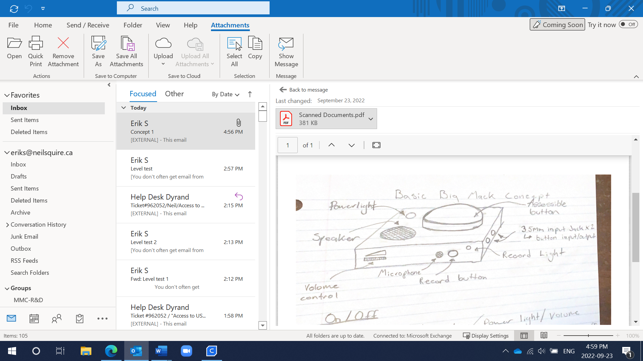

## Idea #2: Modular design utilizing external switches.

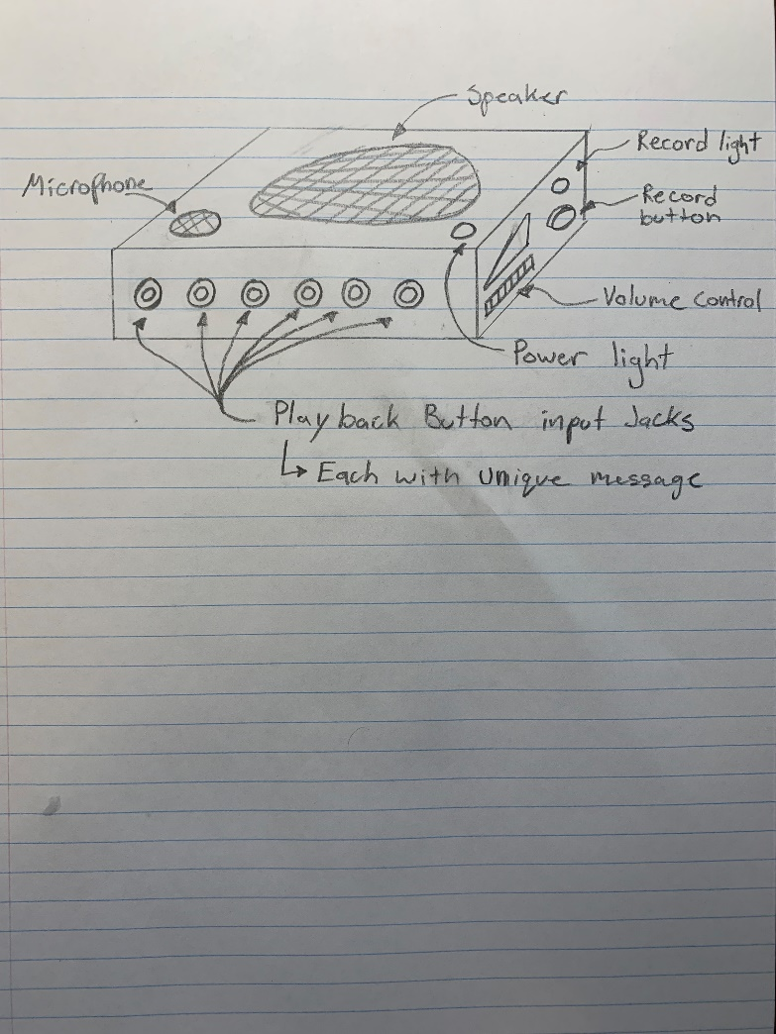

Instead of fitting all the electronics inside a large button, another idea could be to have a single unit to handle message recording and playback. An array of external buttons could then be plugged into one or many of the 3.5 mm input jacks. Each button would control its own message or sequential list of messages. This would allow for more space to fit larger speakers and electronics. The large assessable button would become its own device to be designed.

# Conceptual Design

## Options for Audio Recording and Playback

### Option 1: Use of Voice Record and Playback Module

|  |  |  |  |
| --- | --- | --- | --- |
| **System** | **Possible Product** | **Notes:** | **Cost** |
| Voice Record and Playback | [SEN0197 DFRobot | Development Boards, Kits, Programmers | DigiKey](https://www.digikey.ca/en/products/detail/dfrobot/SEN0197/6588582) | SEN0197   * 10s Record time * Connects easily with Arduino | ~$10 |
| [NC-ISD1620B Nuvoton Technology Corporation | Development Boards, Kits, Programmers | DigiKey](https://www.digikey.ca/en/products/detail/nuvoton-technology-corporation/NC-ISD1620B/1228829) | NC-ISD1620B   * Single message * 6.6s to 40s record time | ~$10 |
| [107020007 Seeed Technology Co., Ltd | Development Boards, Kits, Programmers | DigiKey](https://www.digikey.ca/en/products/detail/seeed-technology-co-ltd/107020007/12177149) | Grove – Recorder V2.)   * Volume control * 8Ω/2W Speaker * 8s to 20s record time | ~$10 |
| Overall Notes | These modules are simple and easy to use while remaining inexpensive but may be to limiting functionally. As part of the requirements for this project, 4 minutes of record time is needed but these modules are intended for much shorter recordings. | | **Total**  ~$30 |

### Option 2: Use of Micro SD Storage

|  |  |  |  |  |
| --- | --- | --- | --- | --- |
| **System** | **Component** | **Possible Product** | **Notes:** | **Cost** |
| Controller | Arduino Micro | [A000053 Arduino | Development Boards, Kits, Programmers | DigiKey](https://www.digikey.ca/en/products/detail/arduino/A000053/4486332) | Cheaper options? | ~$25 |
| Audio Playback | Audio Amplifier  Module | [2130 Adafruit | Mouser Canada](https://www.mouser.ca/ProductDetail/485-2130) | Pam8302A:   * Mono sound * Shut off capabilities | ~$6 |
| Speaker | [3351 Adafruit | Mouser Canada](https://www.mouser.ca/ProductDetail/485-3351) | 3W 4 Ohm, 2.8” x 1.2”   * Easy to mount * Recommended for Pam8302A or MAX98357A | ~$6 |
| Potentiometer:  Volume Control | [3395 Adafruit | Mouser Canada](https://www.mouser.ca/ProductDetail/485-3395) | * 10K * Includes switch for on/off * Clicks in off position | ~$2 |
| Audio Recording/  Storage | Micro Sd Reader: | [254 Adafruit | Mouser Canada](https://www.mouser.ca/ProductDetail/485-254) | Built in 3v-5v regulator | ~$10 |
| Micro Sd Card:  Message Storage | [COM-15107 SparkFun | Mouser Canada](https://www.mouser.ca/ProductDetail/474-COM-15107) | 1GB but many size options | ~$10 |
| Mic with Amp | [1713 Adafruit | Mouser Canada](https://www.mouser.ca/ProductDetail/485-1713) |  | ~$10 |
| Overall Notes | There is an added cost and complexity to using an SD card for storage. This solution requires an SD card module, SD card, audio recording module and must use a micro controller. However, this concept allows the full control of functionality. It will be possible to add modes for multiple message capabilities, i.e.: Big Mack mode, step by step mode, voice repeat mode, etc. Almost no limit on record time. | | | **Total**  ~70 |

## Playing Audio Files

**Recording and Playing Audio with Wav Files**

For the Arduino use wav files for audio recording and playback, the TMRpcm library must be downloaded and used. This library is capable of reading wav files off an SD card and outputting the audio signal through a selected port on the Arduino. It must be noted that by default, the audio recording capabilities are disabled. To enable these features, the library configurations must be edited.

In the file pcmConfig.h file, there are two sections that must be edited:

In the General User Defines section, the “//#define buffSize 128” line of code must be uncommented by removing the “//” from in front.

In the Advanced User Defines section, at the bottom, lines “//#define ENABLE_RECORDING” and “//#define BLOCK_COUNT 10000UL” must also be uncommented.

## **Using Audacity to Add Sound Indicators**

Audacity is a program that can be used to create audio files. If these files are going to be played from the Arduino using the TMRpcm library, the files must be created and saved correctly.

### Step 1.

At the bottom right corner, select **Project Rate (Hz)**, and set to **3200, 22050, 16000, or 11025**

Note: 16000 Hz is the default sample rate for the TMRpcm library.

### Step 2.

At the top of the screen, click **Tracks** -> **Add New** -> and select **Mono Track**. Create one or more of the mono tracks to create the sound file

### Step 3.

Once the sound is complete, click **File** -> **Export** -> **Export Audio…** -> save as type: **Other uncompressed files**, Header: **WAV**, Encoding: **Signed 8-bit PCM**

The audio file can now be saved and added to the device Micro SD card to be used by the TMRpcm library.

# V0.1 Proof-of-Concept Prototype

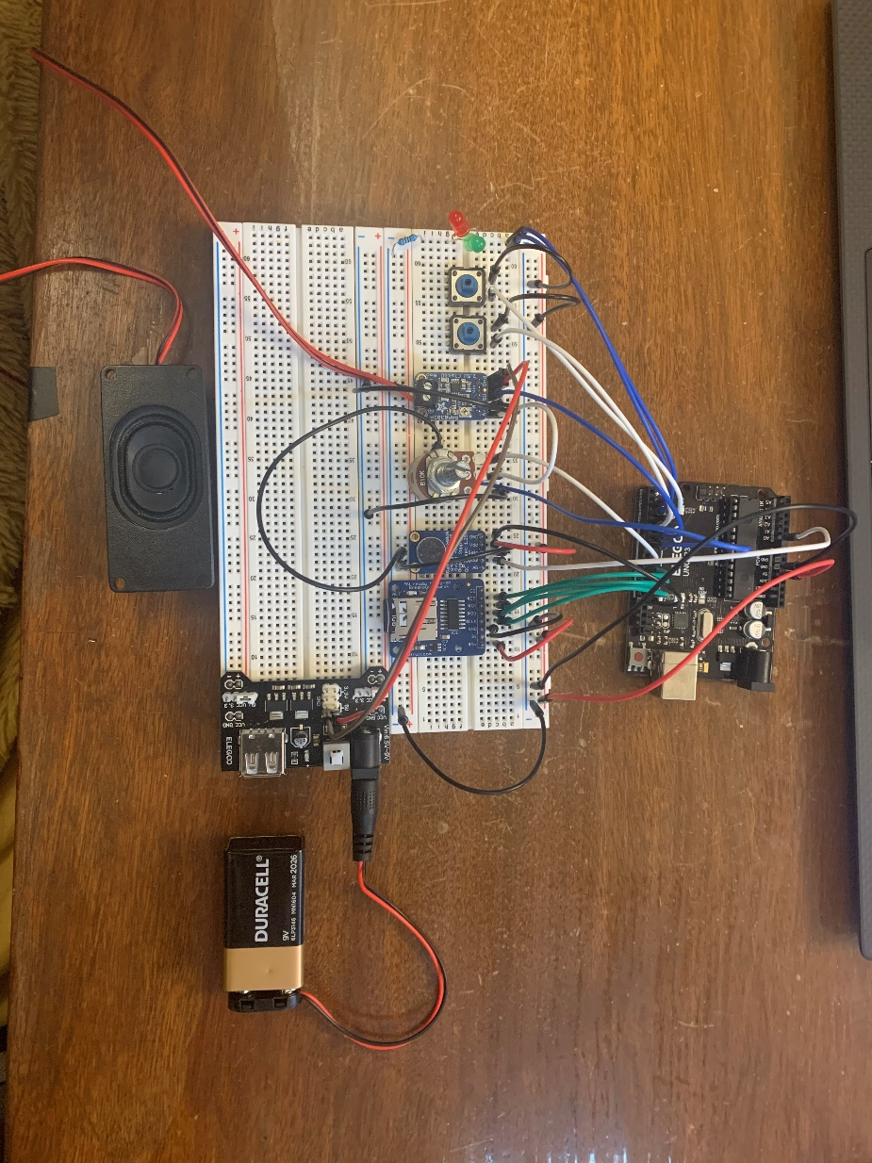

POC Components

|  |  |  |  |
| --- | --- | --- | --- |
| **System** | **Component** | **Possible Product** | **Notes:** |
| Controller | Micro Controller | Arduino Uno | Cheaper options? |
| Audio Playback | Audio Amplifier  Module | [2130 Adafruit | Mouser Canada](https://www.mouser.ca/ProductDetail/485-2130) | Pam8302A:   * Mono sound * Shut off capabilities |
| Speaker | [3351 Adafruit | Mouser Canada](https://www.mouser.ca/ProductDetail/485-3351) | 3W 4 Ohm, 2.8” x 1.2”   * Easy to mount. * Recommended for Pam8302A or MAX98357A |
| Capacitor |  | Protect speaker amplifier input voltage.   * For use with PAM8302A 0.1uF to 0.22uF is ideal * low leakage tantalum or ceramic capacitor is the best choice |
| Potentiometer:  Volume Control | [3395 Adafruit | Mouser Canada](https://www.mouser.ca/ProductDetail/485-3395) | * 10K Ohm * Includes switch for on/off. * Clicks in off position |
| Audio Recording/  Storage | Micro SD Reader: | [254 Adafruit | Mouser Canada](https://www.mouser.ca/ProductDetail/485-254) | * Built in 3v-5v regulator. * Connects to SPI pins |
| Micro SD Card:  Message Storage | [COM-15107 SparkFun | Mouser Canada](https://www.mouser.ca/ProductDetail/474-COM-15107) | 1GB but many size options |
| Mic with Amp | [1713 Adafruit | Mouser Canada](https://www.mouser.ca/ProductDetail/485-1713) |  |
| Basic Control | Playback Button | [B3F-5050 Omron Electronics | Mouser Canada](https://www.mouser.ca/ProductDetail/Omron-Electronics/B3F-5050?qs=dOLq8QE0Pqqk%2FO9x2OpTQw%3D%3D) | Simple press button |
| Record Button |
| Power/Play Light | [LTL2R3KGD-EM Lite-On | Mouser Canada](https://www.mouser.ca/ProductDetail/Lite-On/LTL2R3KGD-EM?qs=xb8aMrBSZRJFqGZErUW7HQ%3D%3D) | Simple red and green LED’s |
| Record Light | [LTL2R3KRD-EM Lite-On | Mouser Canada](https://www.mouser.ca/ProductDetail/Lite-On/LTL2R3KRD-EM?qs=xb8aMrBSZRL5MG5wqCOHaQ%3D%3D) |

## POC Wiring Diagram

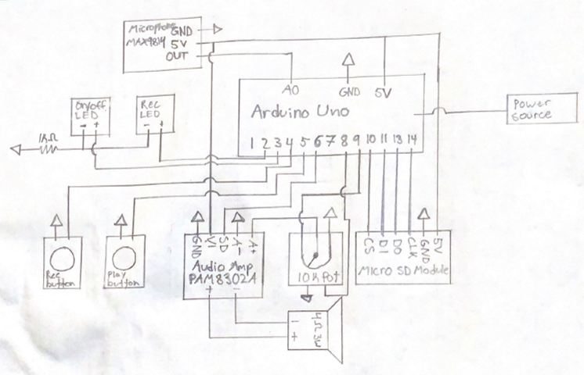

## **POC Device Functionality**

Controls: **Playback Button:** play button for primary user

**Record Button:** small button for secondary user

**Volume Knob:** small dial for secondary user

Indicators: **Power/Playback light:** Green LED

**Record light:** Red LED

Functionality: **Power On/Off:** small dial for secondary user.

* Turn volume knob past minimum to power on device.
  + Power light turns on.
  + Turning the dial controls the volume output.
* Clicking the dial into the minimum position turns the device off.
  + All lights turn off.

**Record Mode:** Accessed via record button.

* + - Hold *Record* *Button* for 2 seconds to engage record mode
      * Messages in storage are deleted.
      * Record light turns on.
    - Press and hold *Playback Button* to record a message.
      * Record light flashes during recording.

**Message Playback:** Accessed via play button.

* + - Press playback button to play message.
      * Each trigger plays next message in queue.
      * Goes back to first message after last message in queue is played.

# V0.2 MVP Design

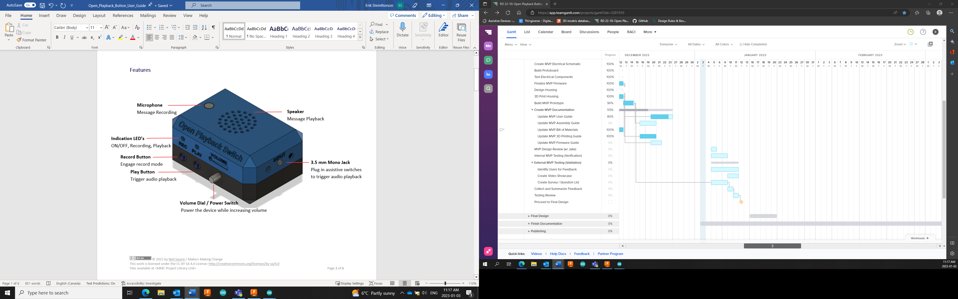

## MVP Components

|  |  |  |
| --- | --- | --- |
| **Component** | **Cost** | **Link** |
| Micro Controller (Arduino Micro) | $30.50 | [A000093 Arduino | Mouser Canada](https://www.mouser.ca/ProductDetail/782-A000093) |
| Audio Amplifier (Pam8302) | $5.45 | [2130 Adafruit | Mouser Canada](https://www.mouser.ca/ProductDetail/485-2130) |
| Mono Speaker (4Ω 3W ) | $5.45 | [3351 Adafruit | Mouser Canada](https://www.mouser.ca/ProductDetail/485-3351) |
| Potentiometer with Switch (Log) | $2.07 | [3481 Adafruit | Mouser Canada](https://www.mouser.ca/ProductDetail/485-3481) |
| Micro SD Reader | $10.35 | [254 Adafruit | Mouser Canada](https://www.mouser.ca/ProductDetail/485-254) |
| Micro SD Card | $9.49 | [COM-15107 SparkFun | Mouser Canada](https://www.mouser.ca/ProductDetail/474-COM-15107) |
| Microphone (MAX9814) | $10.97 | [1713 Adafruit | Mouser Canada](https://www.mouser.ca/ProductDetail/485-1713) |
| Buttons (B3F-5050) | $1.52 | [B3F-5050 Omron Electronics | Mouser Canada](https://www.mouser.ca/ProductDetail/Omron-Electronics/B3F-5050?qs=dOLq8QE0Pqqk%2FO9x2OpTQw%3D%3D) |
| 3.5 mm Mono Jack | $1.95 | [35RAPC2AV Switchcraft | Mouser Canada](https://www.mouser.ca/ProductDetail/Switchcraft/35RAPC2AV?qs=I3kMT7EEIOWP5G1fR6CxcA%3D%3D) |
| Green LED (5 mm) | $0.44 | [LTL2R3KGD-EM Lite-On | Mouser Canada](https://www.mouser.ca/ProductDetail/Lite-On/LTL2R3KGD-EM?qs=xb8aMrBSZRJFqGZErUW7HQ%3D%3D) |
| Red LED (5 mm) | $0.44 | [LTL2R3KRD-EM Lite-On | Mouser Canada](https://www.mouser.ca/ProductDetail/Lite-On/LTL2R3KRD-EM?qs=xb8aMrBSZRL5MG5wqCOHaQ%3D%3D) |
| Resistor (1k Ω) | $0.66 | [MBA02040C1001FRP00 Vishay / Beyschlag | Mouser Canada](https://www.mouser.ca/ProductDetail/Vishay-Beyschlag/MBA02040C1001FRP00?qs=LkqrmUh5PILp63ntvCnX0w%3D%3D) |
| Proto Half Breadboard | $6.21 | [1609 Adafruit | Mouser Canada](https://www.mouser.ca/ProductDetail/485-1609) |
| Male Through Hole Header | $0.80 | <https://www.mouser.ca/ProductDetail/910-HDR100IMP40MGVTH> |
| Female Through Hole Header | $3.80 | [HDR100IMP40F-G-V-TH Chip Quik | Mouser Canada](https://www.mouser.ca/ProductDetail/Chip-Quik/HDR100IMP40F-G-V-TH?qs=Wj%2FVkw3K%252BMB%252BpQKGESbrjQ%3D%3D) |
| **Notes:** | The MVP device uses many of the same electrical components as the POV. The key differences are:   * A logarithmic potentiometer is used for increased volume control. * An Arduino Micro is used to decrease the size. * A mono jack is wired in parallel to the Play Button. * Electrical components are soldered to a protoboard. * Powered by a 9V battery in series with the power switch. | |

## MVP Wiring Diagram

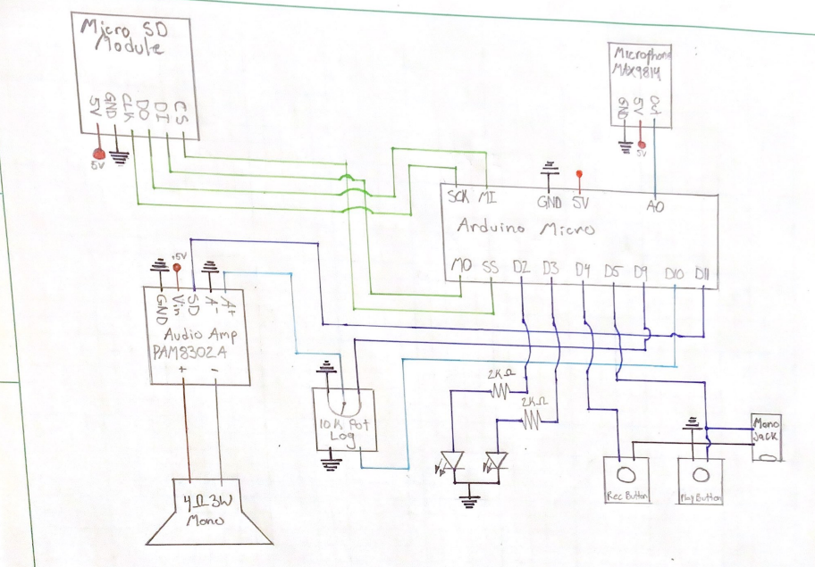

## Feature Set

* Modular (i.e., standalone)

The MVP will be a modular device intended to be used with external switches connected to a 3.5 mm mono jack

### User Controls

* Input Jack
* Playback / Test Button
* Recording Button
* Volume Knob
  + Integrated power control

### Indicators

* PLAY LED
  + Green LED
  + Turns on while device is on
  + Flashes during message playback
* REC LED
  + Red LED
  + Turns on while in record mode
  + Flashes during message recording

### Operating the device

#### Power On/Off

* Turn volume knob fully counterclockwise until it clicks to turn off device
* Turn

#### Record Mode

* Hold Record Button for 2 seconds to engage record mode
  + Messages in storage are deleted
  + Record light turns on
  + Press and hold *Playback Button* to record a message
    - Record light flashes during recording

#### Message Playback

* Press playback button to play message
  + Each trigger plays next message in queue
  + Goes back to first message after last message in queue is played.

## Testing

Recording is great; tricky to replace batteries

One box, multiple switches

**Grandview testing**

“The recorder is great!  It was a bit tricky changing the battery because of all the wires and the challenge of not being able to open it all the way, but the sound quality and volume adjustment and general use are really easy!

It would be really neat to have one box where you could plug in two switches for different messages but that would probably be way more complicated.

“It's such a great device!!!!”

## Opportunities for Improvement

1. Battery cover for easy replacement.
2. Separate power/volume control switches.
3. Volume knob for volume potentiometer.
4. Multiple input jacks.
5. ¼”-20 mount

# V0.3 Design

## Component Considerations

To reduce cost, complexity, and meet some of the opportunities for improvement from the MVP, the following components will be investigated to determine if there are more suitable options:

* Micro Controller
* Microphone
* SD Card Reader
* SD Card
* Audio Amplifier
* Speaker
* LED Indicators
* Volume Potentiometer
* 3-way switch
* On/off switch

### Microcontroller Options

|  |  |  |  |  |
| --- | --- | --- | --- | --- |
| **Possible Product** | **Cost** | **Power Output** | **Input Voltage** | **Notes:** |
| [Arduino Micro (Used with MVP)](https://www.mouser.ca/ProductDetail/Arduino/A000093?qs=B4lwOSfBLoKJean8vPGHVA%3D%3D) | ~$30 | 2.7 – 5.5V | 7 – 12V | Convenient choice while prototyping but not necessarily the best choice based on the price. |
| [Adafruit Feather Adalogger](https://www.mouser.ca/ProductDetail/Adafruit/2795?qs=xE9dPqTLfL5QKg8UliiWEg%3D%3D) | ~30 | 3.3V Only | 5V USB or 4.2/3.7V Lipo | This board is being considered due to its integrated MicroSD reader. This saves the cost and complexity of wiring an external SD reader to the protoboard. However, this board can only output 3.3V which is not enough for the audio amplifier, which will result in an added cost to properly power it. |
| [Arduino Nano](https://www.mouser.ca/ProductDetail/Arduino/ABX00033?qs=PzGy0jfpSMueXyfBfl2XSA%3D%3D) | ~$22.00 | 5V | 6 – 20V | Similar to the Micro. Will work for this project. |
| [Seeeduino Nano](https://www.mouser.ca/ProductDetail/Seeed-Studio/102010268?qs=%252B6g0mu59x7KIlg%252BxI6sM2Q%3D%3D) | ~$10.50 | 5V | 6 – 20V | This inexpensive board has the identical pinouts to the Arduino Nano and should be compatible with all other components. |
| [QT PY SAMD 21](https://www.mouser.ca/ProductDetail/Adafruit/4600?qs=hd1VzrDQEGi752M4exorSA%3D%3D) | ~10.50 | 3.3 – 5V | 5V | There are a series of small microcontroller like this one from $5 - $15. This could help reduce the size of the device but does not have enough I/O pins. |
| **Final Selection** | As the **Seeeduino Nano** is the most similar and inexpensive microcontroller considered, it will be the board used for this final version. | | | |

### Microphone Options

|  |  |  |  |  |
| --- | --- | --- | --- | --- |
| **Possible Product** | **Cost** | **Input Voltage** | **Impedance** | **Notes:** |
| [MAX9814 (Used with MVP)](https://www.mouser.ca/ProductDetail/Adafruit/1713?qs=GURawfaeGuArxgrgUGiqIw%3D%3D) | ~$11.00 | 2.7 – 5.5V |  | Includes amp.  Automatic gain control |
| [MAX4466](https://www.mouser.ca/ProductDetail/Adafruit/1063?qs=GURawfaeGuDfuUUmMlF1tA%3D%3D) | ~$10.50 | 2.4 – 5V |  | Includes amp.  Fixed gain |
| **Final Selection** | Both microphones include an amplifier and gain control at a very similar price. We will proceed with the **MAX9814** as it worked well with the MVP and performs well with noisy backgrounds. | | | |

### Micro SD Card Reader Options

|  |  |  |  |  |
| --- | --- | --- | --- | --- |
| **Possible Product** | **Cost** | **Power Input** | **Interface Type** | **Notes:** |
| [Adafruit 254 Micro SD Board (Used with MVP)](https://www.mouser.ca/ProductDetail/Adafruit/254?qs=GURawfaeGuAkwqCF4BmPzA%3D%3D) | ~$10.50 | 3.3V or 5V | SPI or SDIO |  |
| [Adafruit 4682 Micro SD Board](https://www.mouser.ca/ProductDetail/Adafruit/4682?qs=hWgE7mdIu5TtvwzYJhYD8g%3D%3D) | ~$4.00 | 3.3V Only | SPI or SDIO | Won’t work with current micro controller directly |
| [SparkFun DEV-13743](https://www.mouser.ca/ProductDetail/SparkFun/DEV-13743?qs=WyAARYrbSna7AKzdOk0X8g%3D%3D) | ~$8.00 | 5V Only | SPI |  |
| [SparkFun BOB-00544](https://www.mouser.ca/ProductDetail/SparkFun/BOB-00544?qs=WyAARYrbSnZK7N50UQw0UQ%3D%3D) | ~6.50 | 3.3V Only | SPI | Won’t work with current micro controller directly |
| **Final Selection:** | Both boards that can operate using 5V are suitable for the final version. As the price difference between them is minimal, it will be best to proceed with the **Adafruit 254** version. | | | |

### Micro SD Card Options

|  |  |  |  |
| --- | --- | --- | --- |
| **Possible Product** | **Cost** | **Storage** | **Notes:** |
| [SparkFun COM-15107 (Used with MVP)](https://www.mouser.ca/ProductDetail/474-COM-15107) | ~$9.50 | 1GB | More storage than necessary |
| [5249 Adafruit Micro SD](https://www.mouser.ca/ProductDetail/Adafruit/5249?qs=Rp5uXu7WBW%252B%2FlGiDAlYVUg%3D%3D) | ~$5.00 | 64Mb |  |
| [5250 Adafruit Micro SD](https://www.digikey.ca/en/products/detail/adafruit-industries-llc/5250/15794636) | ~$5.50 | 128Mb | Not stocked by Mouser |
| [5251 Adafruit Micro SD](https://www.digikey.ca/en/products/detail/adafruit-industries-llc/5251/15841479) | ~$6.00 | 256Mb | Not Stocked by Mouser |
| [5252 Adafruit Micro SD](https://www.digikey.ca/en/products/detail/adafruit-industries-llc/5252/15841478) | ~$7.00 | 512Mb |  |
| **Final Selection:** | As message storage does not require much storage, the **64Mb option** still fits within the scope if this project and is the most inexpensive option. | | |

### Audio Amplifier Options

|  |  |  |  |  |
| --- | --- | --- | --- | --- |
| **Possible Product** | **Cost** | **Power** | **Impedance** | **Notes:** |
| [PAM8302 (Used with MVP)](https://www.mouser.ca/ProductDetail/Adafruit/2130?qs=GURawfaeGuAERP6YRZwNag%3D%3D) | ~$5.50 | 2.5W | 4Ohm |  |
| **Final Selection** | This amplifier works very well for the current setup as it can operate using the microcontroller power output. If the max volume needs to be increased further, the entire audio output system will need to be upgraded, along with an external power supply. To reduce cost and complexity, we will proceed with the **PAM8402**. | | | |

### Speaker Options

|  |  |  |  |  |
| --- | --- | --- | --- | --- |
| **Possible Product** | **Cost** | **Power** | **Impedance** | **Notes:** |
| [Adafruit Mono Enclosed (Used with MVP)](https://www.adafruit.com/product/3351) | ~$5.50 | 3W | 4Ohm | Enclosed mono speaker |
| [Adafruit Mono Cone](https://www.adafruit.com/product/1314) | ~$3.00 | 3W | 4Ohm | 3” round speaker |
| **Final Selection** | Both speakers considered are ideal for the audio amplifier selected. We well proceed with the **enclosed speaker** as it offers more directional sound output. | | | |

### LED Indicators

|  |  |  |  |  |
| --- | --- | --- | --- | --- |
| **Possible Product** | **Cost** | **Colour** | **Size** | **Notes:** |
| [Dual LED’s (Used with MVP)](https://www.mouser.ca/ProductDetail/Lite-On/LTL2R3KGD-EM?qs=xb8aMrBSZRJFqGZErUW7HQ%3D%3D) | ~$1  ($0.5 per) | 1 red, 1 green | 5 mm | Two LED’s: One for playback/power indication, and the other for record mode/message recording indication. |
| Bi Colour LED | ~$1 | Red/green | 5 mm | Bi colour led that can turn green for message playback and red for recording. |
| **Final Selection** | To avoid confusion between the two LED’s and simplify the user interface, we will proceed with the **Bi colour LED**. | | | |

### Volume Potentiometer

|  |  |  |  |  |
| --- | --- | --- | --- | --- |
| **Possible Product** | **Cost** | **Resistance** | **Taper** | **Notes:** |
| [Adafruit Audio Pot](https://www.mouser.ca/ProductDetail/485-3481) | $2.07 | 10KOhm | Log | Includes on/off switch for power |
| [BI Tech Pot](https://www.mouser.ca/ProductDetail/BI-Technologies-TT-Electronics/P160KNP-0QC20A10K?qs=56eeD6vBg8hi4UUaifEZ4Q%3D%3D) | $2.39 | 10KOhm | Audio |  |
| **Final Selection** | We will not include integrated power control in the volume dial, therefore a on/off switch is not required. | | | |

### 3-Position Switch

|  |  |  |  |  |
| --- | --- | --- | --- | --- |
| **Possible Product** | **Cost** | **Switch Function** | **Type** | **Notes:** |
| [G-1328S-0000 CW Industries | Mouser Canada](https://www.mouser.ca/ProductDetail/CW-Industries/G-1328S-0000?qs=n1d6TrdN4SDIbOI8F4R%252B2A%3D%3D) | $3.16 | ON-ON-ON | Slide | Screw holes for easy mounting |
| [S112032SS03Q C&K | Mouser Canada](https://www.mouser.ca/ProductDetail/CK/S112032SS03Q?qs=mfFuHy8STfJaTzKPmafJ7w%3D%3D) | $5.80 | ON-OFF-ON | Slide | Screw holes for easy mounting |
| [G-329L-0019 CW Industries | Mouser Canada](https://www.mouser.ca/ProductDetail/CW-Industries/G-329L-0019?qs=n1d6TrdN4SBViBPpaPgSiw%3D%3D) | $2.44 | ON-ON-ON | Slide | Screw holes for easy mounting. Single pole, triple throw. |
| **Final Selection** | We will use the **third** option considered. More information can be found page 17 of the following recourse: [Standard Switch Catalog S2120II03.doc (cwind.com)](https://www.cwind.com/pdf/Standard-Switch-Catalog-S2120-II-03-2.pdf) | | | |

### On/Off Switch

|  |  |  |  |  |
| --- | --- | --- | --- | --- |
| **Possible Product** | **Cost** | **Switch Function** | **Mount Style** | **Notes:** |
| [C1300ALAAA Bulgin | Mouser Canada](https://www.mouser.ca/ProductDetail/Bulgin/C1300ALAAA?qs=T3oQrply3y%252B3LOJGozZqzg%3D%3D) | $1.95 | ON-OFF | Snap In |  |
| [RA11131123 E-Switch | Mouser Canada](https://www.mouser.ca/ProductDetail/E-Switch/RA11131123?qs=QtyuwXswaQhc6OwdGDJDiQ%3D%3D) | $0.93 | ON-OFF | Snap In | Has ON and OFF written on the side for easy use. |
|  |  |  |  |  |
| **Final Selection** | We will use the **second** option. | | | |

## Component Selection

|  |  |  |  |  |  |
| --- | --- | --- | --- | --- | --- |
| **System** | **Component** | **Selected Product** | **Quantity** | **Cost** | **Notes** |
| Controller | Micro Controller | [Seeeduino Nano](https://www.mouser.ca/ProductDetail/Seeed-Studio/102010268?qs=%252B6g0mu59x7KIlg%252BxI6sM2Q%3D%3D) | 1 | $10.49 | * Identical pinout to the Arduino Nano |
| Audio Playback | Audio Amplifier | [PAM8302](https://www.mouser.ca/ProductDetail/Adafruit/2130?qs=GURawfaeGuAERP6YRZwNag%3D%3D) | 1 | $5.45 | * 2.5W Class D |
| Speaker | [Adafruit Mono Enclosed](https://www.mouser.ca/ProductDetail/485-3351) | 1 | $5.45 | * 3W 4Ohm enclosed mono speaker |
| Message Storage | Micro SD Reader | [Adafruit MicroSD Reader](https://www.mouser.ca/ProductDetail/485-254) | 1 | $10.35 | * 3V/5V regulator * SPI |
| Micro SD Card | [Adafruit MicroSD Card](https://www.mouser.ca/ProductDetail/Adafruit/5249?qs=Rp5uXu7WBW%252B%2FlGiDAlYVUg%3D%3D) | 1 | $4.83 | * 64Mb |
| Message Recording | Microphone/Amplifier | [MAX9814](https://www.mouser.ca/ProductDetail/485-1713) | 1 | $10.97 | * Integrated amplifier and automatic gain control |
| User Inputs | Volume Control | [10K Audio Pot](https://www.mouser.ca/ProductDetail/BI-Technologies-TT-Electronics/P160KNP-0QC20A10K?qs=56eeD6vBg8hi4UUaifEZ4Q%3D%3D) | 1 | $2.13 | * Log taper for audio control |
| Play/Record Buttons | [B3F-5050 Buttons](https://www.mouser.ca/ProductDetail/Omron-Electronics/B3F-5050?qs=dOLq8QE0Pqqk%2FO9x2OpTQw%3D%3D) | 2 | $1.52  ($0.76 per) | * Simple to solder and use * Easily mountable to enclosure |
| Switch Inputs | [3.5 mm Mono Jack](https://www.mouser.ca/ProductDetail/Switchcraft/35RAPC2AV?qs=I3kMT7EEIOWP5G1fR6CxcA%3D%3D) | 1 | $2.13 | * Standard for assistive switches * Threaded ring for easy mounting |
| Power Control | [On/Off Switch](https://www.mouser.ca/ProductDetail/E-Switch/RA11131123?qs=QtyuwXswaQhc6OwdGDJDiQ%3D%3D) | 1 | $0.93 | * Snap in rocker switch. * On/off labels |
| Level Control | [3 Position Switch](https://www.mouser.ca/ProductDetail/CW-Industries/G-329L-0019?qs=n1d6TrdN4SBViBPpaPgSiw%3D%3D) | 1 | $2.44 | * 3 position slide switch with detents |
| Visual Indicators | Play/Record Light | [Bi Colour RG LED](https://www.mouser.ca/ProductDetail/Kingbright/WP819SURKMGKW?qs=58z0TXQGVSRLNoI%2FJv9TJg%3D%3D) | 1 | $0.98 | * Red / Green LED |
| Power Supply | 9V Battery | [Consumer 9V](https://www.mouser.ca/ProductDetail/Duracell/MN1604?qs=sGAEpiMZZMuXcNZ31nzYhRxIBnh8NwTszWVrE18PlWU%3D) | 1 | $3.48 | * Any standard 9V battery will work |
| Battery Connector | [9V Battery Clip](https://www.mouser.ca/ProductDetail/563-HH-3449) | 1 | $1.79 | * Simple clip for connecting the battery |
| Assembly | Protoboard | [Proto Half Breadboard](https://www.mouser.ca/ProductDetail/485-1609) | 1 | $6.21 | * Smallest size that can connect the micro controller, SD reader, and audio amp. |
| Male Headers | [Male Through Hole](https://www.mouser.ca/ProductDetail/910-HDR100IMP40MGVTH) | 2 | $1.60  ($0.80 per) | * Used for micro controller, audio amp and SD card reader |
| Female Headers | [Female Through Hole](https://www.mouser.ca/ProductDetail/Chip-Quik/HDR100IMP40F-G-V-TH?qs=Wj%2FVkw3K%252BMB%252BpQKGESbrjQ%3D%3D) | 2 | $3.80  ($1.90 per) | * Used for micro controller, audio amp and SD card reader. |
| Resistors | [2K ohm Resistor](https://www.mouser.ca/ProductDetail/Vishay-Beyschlag/MBA02040C2001FCT00?qs=Q%252BviyuKCy%2FwudcV7dCRvqQ%3D%3D) | 2 | $0.66  ($0.33 per) | * Any standard 9V battery will work |
| Screws |  |  | $ |  |
|  |  |  | $ |  |
|  |  |  | $ |  |

## Enclosure Design

The enclosure requires the following features:

* Input Jack (IMP)
* LED
* 2X Button (BUT)
* Volume Potentiometer (VOL)
* Microphone (MIC)
* Speaker Holes
* On/Off Switch (PS)
* 3 Position Level Select Switch (LS)

### MVP LAYOUT

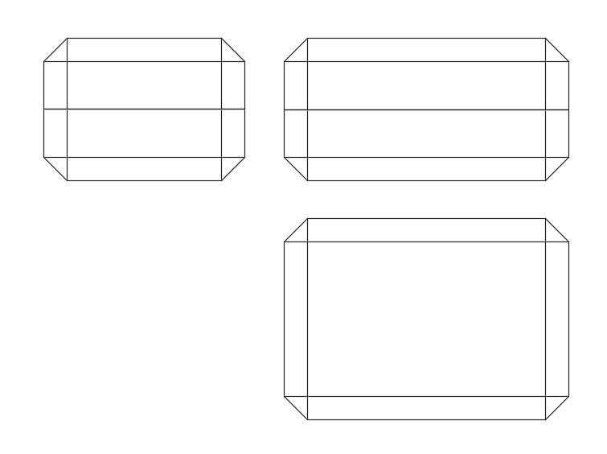

NOTES: Enclosure was made larger to incorporate a battery cover and only one input jack was used.

### Possible Final Layout #1



NOTES:

### Possible Final Layout #2



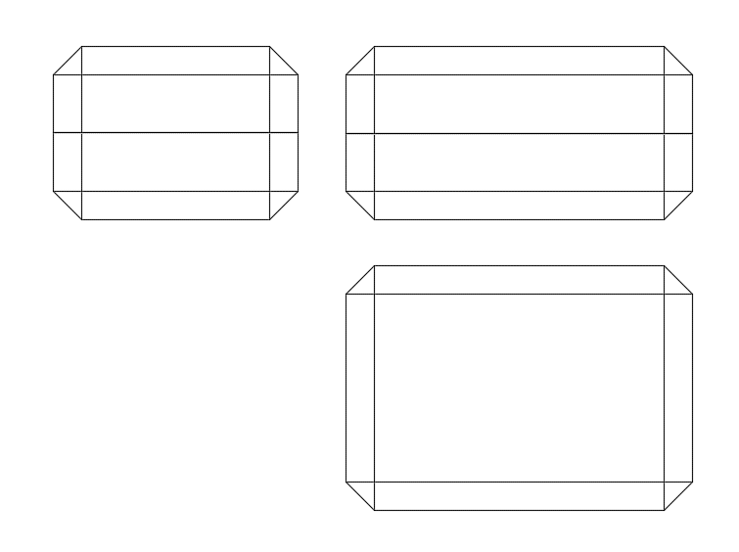



NOTES:

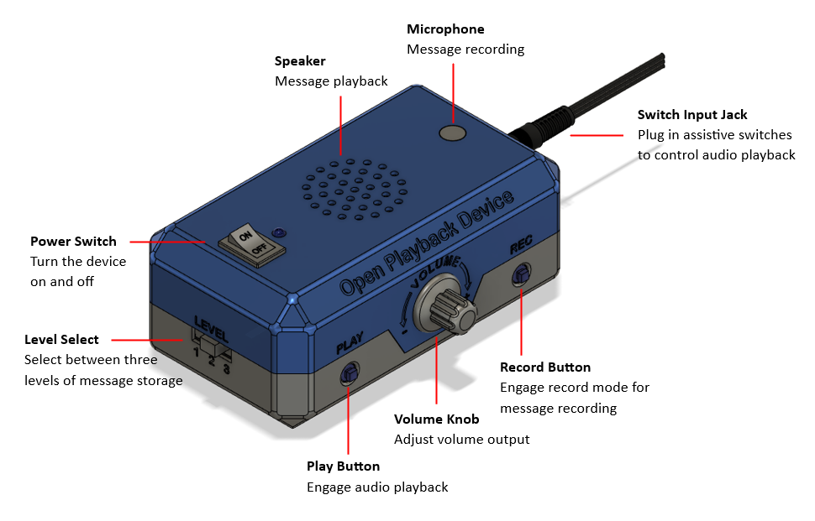

## Sound Indicators

## V0.3 Feature Set

* Similar functionality to the MVP
* 3 level switch has been added to swap between 3 levels of message storage

## Device Naming

Existing Names:

* Big Mack
* Big Step-by-Step
* iTalk
* TalkingBrix
* QuickTalker

Possible Names:

* Open Playback Button
* Open Playback Switch
* Speech Generation Device
* Yak Back – Stephen
* Playback Parrot – Brad
* Record and Play
* Open Playback Device
* Open Playback Record
* Open Playback Recorder
* Multi-message Playback Recorder
* Open Record and Play
* Open Voice Recorder
* Open Audio Recorder
* Audio Record and Play

After running through the name generation exercise, the following names were chosen as possibilities.

* Playback Parrot
* Record and Play
* Command Chronicler
* Rewind Recorder

## Opportunities for Improvement

## Alterative Versions

* Current version focused on recreating the “Big Mack” experience
  + One playback button
  + Sequential lists of messages
  + 3 level select

### Full Feature Version

* Without concern for cost, a full feature version could eliminate some of the limitations of functionality.
* Features to add.
  + Louder speakers
  + Screen to make set up and operation easier
* Multiple Input Jacks
* Output Jacks

### Inexpensive Version

* Instead of using a microcontroller to add functionality to the device, a cheaper rec/playback module could be used.
* Limited record time.
* Limited number of tracks.
* Use of audio output jack to eliminate cost of audio amp and speakers.

### User Interface Changes

* Move recording/playback LED closer to the microphone/away from the power switch so it doesn’t look like a power indicator
* Potentially move level selection from being a slide switch to 3 LEDS and a button/switch to scan through them to give primary user control over level selection

### Maker Experience Changes

* Make all connections between halves of the build in one spot/anchor everything to protoboard so joints don’t snap during assembly

## Questions for Clients

How long do the stored messages need to be?

* Big Mack max length = 2 minutes
* Big Mack Step by Step = 4 minutes
* Pet training buttons = 30 seconds

In what ways will this device be used? In what ways could multiple messages be used?

* Communication aid
* Sequential message storage: E.g., recording steps of a recipe
* Speak therapy: record and listen

Would mono cable input jacks be useful to the user?

* Input jack to allow playback activation from external switches
* Input jack to allow the Playback Button to be used as a switch for external devices

Power control integrated with volume knob or not?

* Does volume level need to be consistent?

## **User Feedback**

Status Light

Record Mode entered: Flashes red

Recording: Solid red

Playback: Green

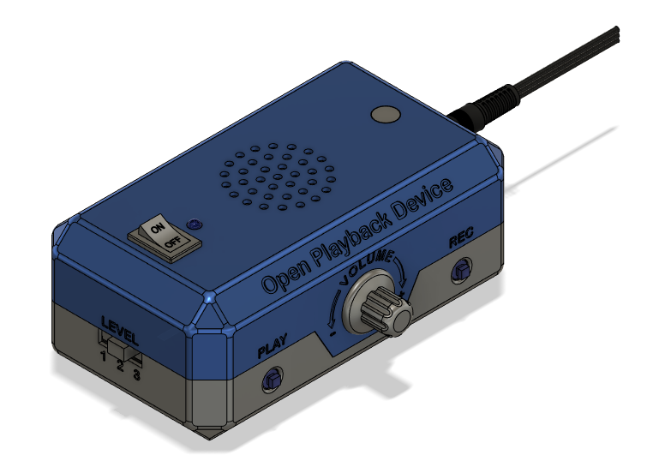

**Power Switch**

Turn the device on and off

**Microphone**

Message recording

**Speaker**

Message playback

**Level Select**

Select between three levels of message storage

**Record Button**

Engage record mode for message recording

**Volume Knob**

Adjust volume output

**Play Button**

Engage audio playback

**Switch Input Jack**

Plug in assistive switches to control audio playback

## Opportunities for Improvement

* Add button to cover tactile buttons
* Fix spelling of Makers Making Change label
* Consider the positioning of record light (i.e., move away from power control to reduce confusion)
* Label microphone (either with words or symbol
* Wire spaghetti with components between top and bottom parts of enclosure

# V1.0

## Goals

* 3 level switch has been added to swap between 3 levels of message storage
  + Slide switch or press button?
* Move record/play LED to more intuitive location so it doesn’t look like a power indicator
* More maker friendly build experience, make one set of cables between halves and reduce the “cheese pull” of wires connecting the two sides
* Consider replacing the microcontroller, SD card reader, and audio amplifier with the Adafruit [Audio BFF](https://www.adafruit.com/product/5769)
* Miscellaneous CAD changes
  + Add shadow lines
  + Add a deboss around the LEDs/button/jack on the press button version
  + Make the battery cover easier to remove
  + Microphone cover

### Level Selector

Two concepts were generated for the level selection. One used a three level slide switch and a resistor ladder connected to an analog input, and one used a push button in parallel with a switch jack to change the level.

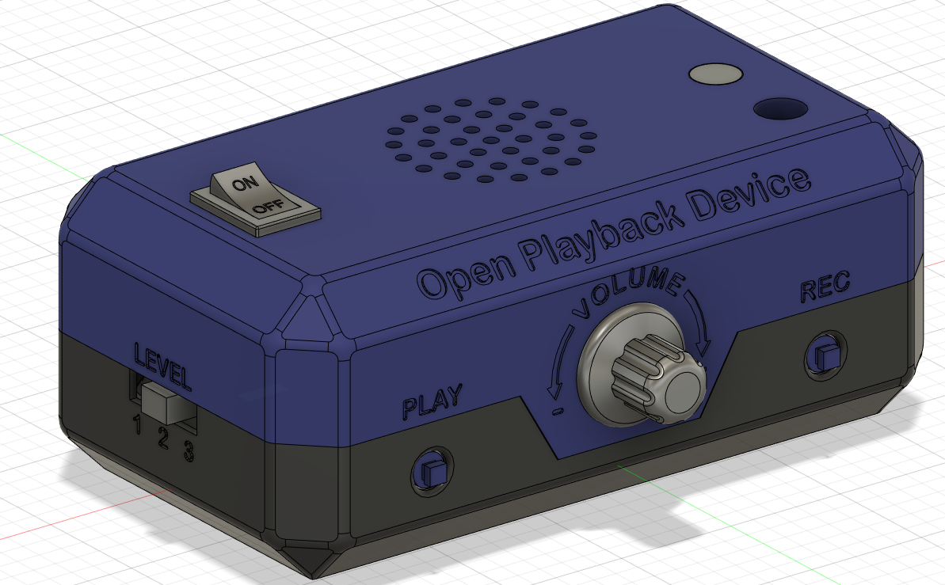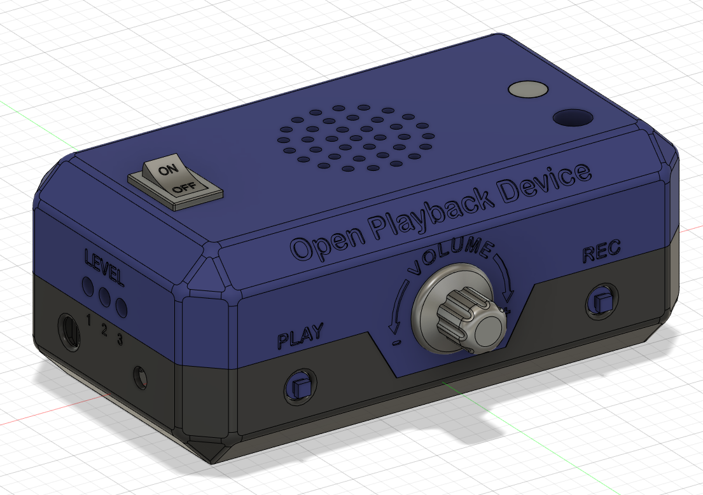

The slide switch indicates the current level to the user with the physical position of the switch, and the push button indicates the position to the user using three LEDs, with one corresponding to each level.

Since the press button is in parallel with a switch jack, the level of the device can be changed by the primary user. Preliminary testing shows that the button does need a hardware debounce, most likely a lowpass filter.

Final selection was the button press, with a redesign of the UI to keep all controls on one side.

### Human Design Factor Update

The record and play LEDs were split into two LEDs to make it more clear which mode is active for colour blind users. All the LEDs and buttons were moved to the front side of the enclosure, with both jacks moved to the same side.

### Maker Friendly Improvements

In the initial prototype, there were roughly 10 wires that connected the two halves. This made it difficult to assemble the two halves, as all the wires had to be inside the enclosure, and the act of opening or closing the enclosure put stress on the more fragile solder joints, repeatedly causing them to break during prototyping. A new design was created that used to protoboards to connect all the wires on each side, then connecting the two protoboards using a ribbon of breadboard wires. This is still very stiff, and there is still room for improvement finding a more flexible cable that allows the halves to close easier.

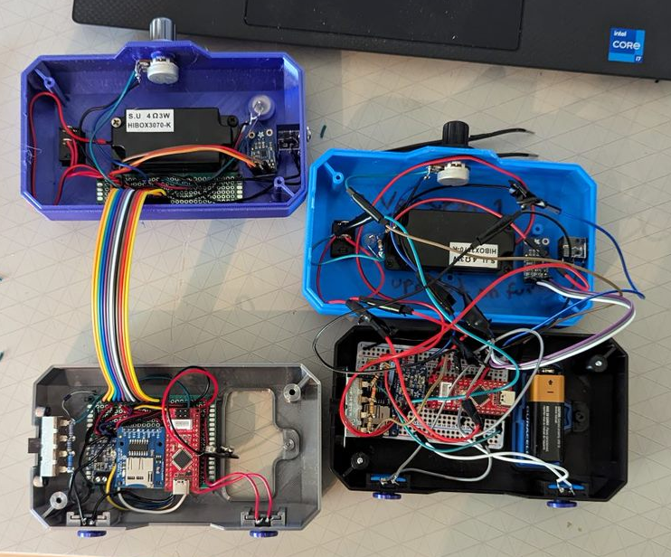

### Alternative Audio Setup

Recently, Adafruit has come out with a device called the [Audio BFF](https://www.adafruit.com/product/5769) board, which is a backpack style expander board for the QT Py or Xiao style microcontrollers. This board contains both a microSD card reader and a MAX98357 audio amplifier. This would replace the current microSD breakout board, and the audio amplifier. The BFF costs around 6 USD, while the microSD breakout and audio amplifier costs around 15 CAD. The microcontroller would also need to be changed to one that matches the BFF footprint. This would cause issues with the number of pins needed for the device. It is possible to get GPIO pin extender, but that would bring the cost of the new solution to roughly the same price.

|  |  |  |  |
| --- | --- | --- | --- |
| Current Setup | | BFF Setup | |
| Part | Price (USD) | Part | Price (USD) |
| [Seeduino Nano](https://www.seeedstudio.com/Seeeduino-Nano-p-4111.html) | 7.60 | [QT Py](https://www.adafruit.com/product/4600) | 7.50 |
| [MicroSD Breakout](https://www.adafruit.com/product/254) | 7.50 | [Audio BFF](https://www.adafruit.com/product/5769) | 5.95 |
| [Audio Amplifier](https://www.adafruit.com/product/2130) | 3.95 | [GPIO Extender](https://www.adafruit.com/product/4886) | 4.95 |
|  |  | [Stemma Cable](https://www.adafruit.com/product/4399) | 0.95 |
| Total Price (USD) | 19.05 | Total Price (USD) | 19.35 |

## Changes

1. Finalize naming
2. ¼”-20 mount?
3. Secondary / Primary User Adjustable Levels?
   * Add an input to switch between levels
   * Add an indicator to indicate which level is selected
   * Could be both tactile button and/or external switch input
4. Output Jack
   1. What is the use case here?
5. Optimize assembly / enclosure to ease wiring
6. Swap from protobreadboard to protoboard

### Final Changes

* Added jack/button for level selection
* Moved all buttons and lights to front face
* Moved all jacks to left side

## OFIs

* Look into rechargeable 9V batteries
* Look into adding an output jack
* May be able to improve BoM by ordering wire by the foot from digikey or mouser

## Final Schematic

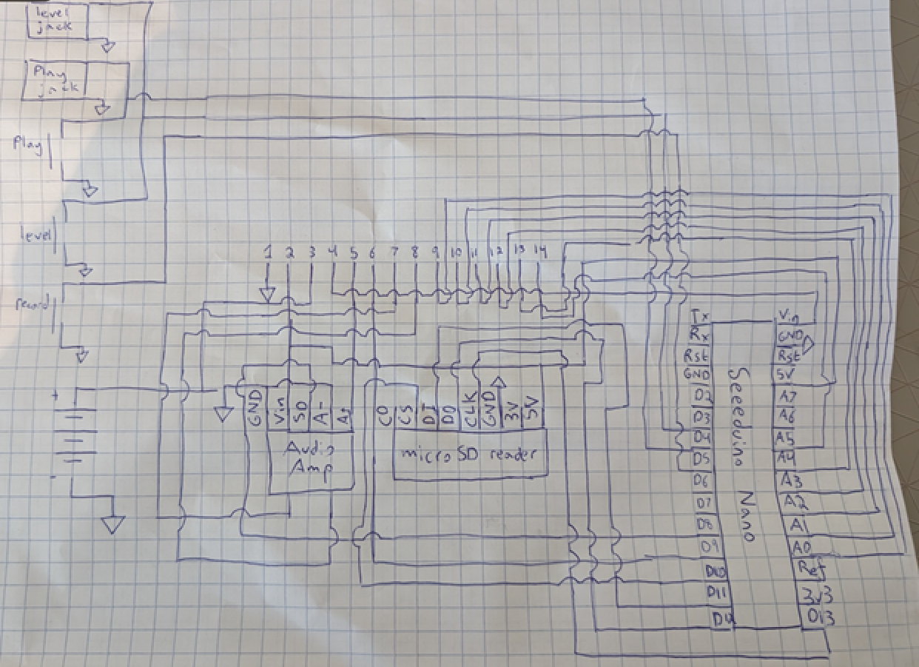

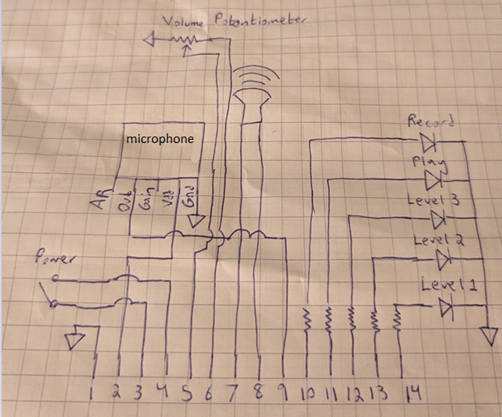

## Code Architecture

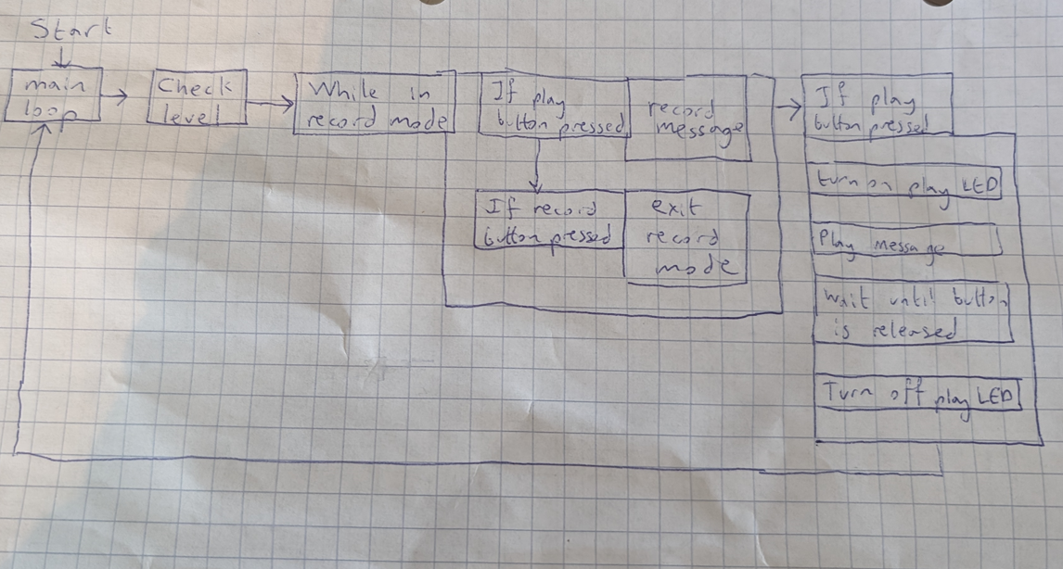

# V2.0

After building several Open Playback Recorders, it was decided that the build process took too long and had too many points of failure, which made it difficult for makers to build the device. It was decided to redesign the internals using a PCB to cut down on the cost and complexity of the device for makers.

## Project Charter

### Purpose

* The Open Playback Recorder has proven to be a popular device, and there have already been over ten requests since the product was launched.
* Current protoboard and DuPont wire design takes ~8 hours to build, which is a significant barrier to makers

### Objectives

* The objective of the project is to maintain the functionality of the Open Playback Recorder but improve the makeability by adding a PCB and re-evaluating the components to reduce opportunities for mistakes

### What Success looks like

* Success would be an updated version of the Open Playback Recorder that maintains the same functionality, but with an improved makeability, with the possibility of a slightly modified form to accommodate the PCB and updated components

## Project Scope

### Deliverables

* PCB Schematics for the updated design
* New BoM with the updated parts list
* Updated Maker Guide with the updated design
* Update the User Guide with updated photos and references if the form changes
* Update GitHub ReadMe
* Updated MMC Library Device page
* Document design update process in Design Rationale
* Updated CAD to accommodate the PCB

### Requirements

* Build time must be cut in half from the protoboard version
* Cost must not be increased by more than 50 dollars
* Number of soldered joints/points of failure must be cut in half.
* User functionality must not be changed.

### Out of Scope

* Any changes to the functionality are out of scope for the project. This project is strictly focused on improving the maker experience, and should have minimal to no effect on the user experience.

## PCB Layout

### Limiting factors

* Eagle Design Space
  + Max area of 80 cm2
* PCB Boardhouse pricing
  + Gets more expensive if not in 10cmx10cm area
* Component spacing in the Open Playback Recorder
  + Base
    - Buttons on front, jacks on side
  + Top
    - LEDs and potentiometer on the front
    - Microphone, power switch, speaker on top

### Current Protoboard Layout

**Base**

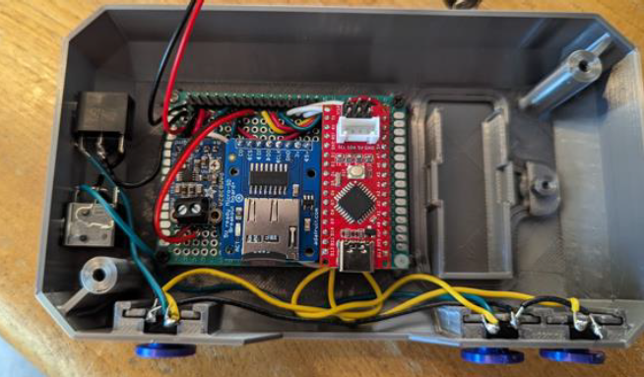

In the top, there is a central protoboard that contains the microSD card, the speaker amplifier, and the microcontroller. The protoboard is mounted in the center of the base, with the buttons and jacks panel mounted and connected to the protoboard via wires.

**Top**

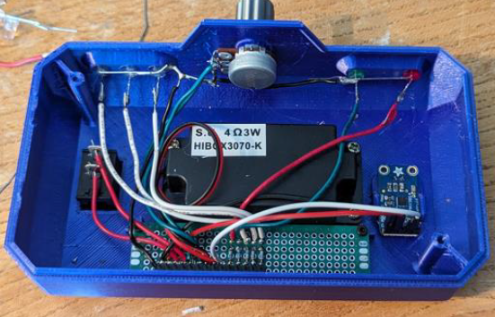

In the top, there is a narrow protoboard for all the panel mount components to connect to. The only components mounted on the board are the resistors and the header that connects the two halves

### Layout Options

#### One PCB

In this layout, there is only one PCB. Either all the components top and bottom are connected to the one PCB via wires like in the initial prototype, or only one of the protoboards is replaced with a PCB. Both options do not reduce the complexity of the device enough to warrant ordering a PCB.

#### Two PCBs

In the two PCB setup, each protoboard is replaced with a PCB

In the bottom, the protoboard is replaced with a single PCB. Given the size restrictions on designing and ordering PCBs, the overall size of the device would have to either shrinks significantly, the user interface components would have to be all moved to one corner of the board, or either the buttons or jacks remain panel mounted.

In the top, the protoboard would be replaced with a PCB. The DuPont header connection would be replaced with a ribbon cable for a more secure connection, with no risk of individual wires being crossed or coming undone. The PCB can either be mounted in the location of the current protoboard, or it can be moved closer to the front of the device to allow the option of PCB mounting the LEDs and the potentiometer.

#### Three PCBs

In the three PCB setup, the top protoboard is replaced with a PCB, and the bottom protoboard is split into two separate PCBs for the buttons and the jacks.

In the bottom, the protoboard would be replaced with two PCBs, one with PCB mounted buttons, and one with panel mounted switch jacks. The other components that were mounted on the protoboard are split between the two PCBs. This allows the PCBs to slot in from the side from one direction, preventing assembly issues from slotting in components from multiple sides at once.

In the top, the protoboard would be replaced with a PCB. The DuPont header connection would be replaced with a ribbon cable for a more secure connection, with no risk of individual wires being crossed or coming undone. The PCB can either be mounted in the location of the current protoboard, or it can be moved closer to the front of the device to allow the option of PCB mounting the LEDs and the potentiometer.

#### More than three PCBs

The option of more than three PCBs will be explored if there are any serious roadblocks with the two or three PCB options that would require another PCB.

### PCB Recommendation

Two PCBs strike a good balance between makeability and price. It allows for both protoboards to be replaced with PCBs and PCB mount most of the components, with the exception of the speaker. A third PCB in the base would allow more flexibility in assembling the device, but the cost of including a third PCB would outweigh the benefits.

## Component Review

### Panel Mount vs PCB Mount

* PCB components reduce complexity, but can make assembly into the enclosure more difficult. (See Forest Hub for example)
* PCB components require the board to extend to the sides of the enclosure for user interface components
* Panel mount components make assembly easy, but need extra wire to get them to the board

### Current User Interface Components

* Bottom
  + Buttons
  + Jacks
* Top
  + Speaker
  + Microphone
  + Power Switch
  + LEDs
  + Potentiometer

### Component Selection

#### User Interface

**Top**

Power Switch

* Current switch [[Link]](https://www.mouser.ca/ProductDetail/E-Switch/RA11131123?qs=QtyuwXswaQhc6OwdGDJDiQ%3D%3D)
* Slide switch [[Link]](https://www.digikey.ca/en/products/detail/c-k/OS102011MA1QN1/1981430)
* Currently mounted on the top, but power is coming from the base, and is consumed at the base. Would make sense for it to be at the bottom.

Speaker

* Wires come from the speaker, connect to the protoboard
* Solder to the protoboard
* Either continue to solder into the board, or add a terminal block to connect the wires to the PCB

LEDs

* Current LEDs can be used both as panel mount or PCB mount. If PCB mount, a spacer like the one used in the Forest Hub would be useful

Potentiometer

* Currently using a panel mounted logarithmic potentiometer [[Link]](https://www.mouser.ca/ProductDetail/858-P160KNP0QC20A10K)
* PCB mounted 10kohm logarithmic potentiometer [[Link]](https://www.digikey.ca/en/products/detail/cui-devices/PTN16-A10125K1A2/20380750)

Microphone

* Currently using electret microphone amplifier [[Link]](https://www.adafruit.com/product/1713)
* Looked for stemma version to reduce soldering but not available

**Bottom**

Jacks

* Current selection [[Link]](https://www.mouser.ca/ProductDetail/Switchcraft/35RAPC2AV?qs=I3kMT7EEIOWP5G1fR6CxcA%3D%3D)
* PCB mounted option [[Link]](https://www.digikey.ca/en/products/detail/cui-devices/SJ1-3535NG/738699?s=N4IgTCBcDaIMIAUCMBaAzAVkwOQOIuwBEQBdAXyA)

Buttons

* Current selection is the button used in the raindrop switch [[Link]](https://www.mouser.ca/ProductDetail/Omron-Electronics/B3F-5050?qs=dOLq8QE0Pqqk%2FO9x2OpTQw%3D%3D)
* PCB mounted button [[Link]](http://www.digikey.ca/product-detail/en/wurth-electronics-inc/431256058736/431256058736-ND)

#### Internal

Microcontroller

* Needs to be 5v for some of the components
* Needs a large amount of pins
* Potential to get one with a built in SD card

MicroSD card reader

* Potential to combine the microSD card reader with the microcontroller
* Potential to

Speaker Amplifier

* Currently using the provided terminal block with wires going to the header. Possibility to replace the terminal block with the same headers used in the data lines providing the spacing is the same.

Battery

* CAD needs to be tweaked to add more tolerance to make the battery cover easier to remove
* Currently using a cable connected to the protoboard [[Link]](https://www.mouser.ca/ProductDetail/Bud-Industries/HH-3449?qs=l8tafrjApPBvV0mmo%252BVZ5Q%3D%3D)
* Possibility to add terminals to the PCB and plug the battery directly into the PCB [[Link]](https://thepihut.com/products/pcb-9v-connector-pair)

### Part Recommendations

**Top**

* Microphone
  + Continue to use the same microphone as before, but solder it directly to the PCB using headers.
* Speaker
  + Continue to use the same speaker as before, soldered to the PCB or using terminal blocks
* LEDs
  + Continue to use the same LEDs as before, but use a 3D printed spacer to get the LEDs in the correct orientation
* Potentiometer
  + 10 kOhm PCB mounted logarithmic potentiometer
  + If possible when doing the PCB layout, move to the bottom of the device to cut the required number of cables in the ribbon from 12 to 10
* Connection
  + Ribbon cable for a secure connection and make it impossible for wires to get crossed
  + Either 10 or 12 wire cable, depending if the potentiometer will fit on the bottom or not

**Bottom**

* Buttons
  + PCB mounted to reduce number of wires and soldered connections.
  + Capture the button covers internally to prevent them from falling off.
* Jacks
  + PCB mounted to reduce number of wires and soldered connections.
  + Move them closer to the front so they fit within the 100mm x 100mm area.
* MicroSD card reader
  + Continue to use the same one as before, but move the port so the SD card is accessible by the secondary user
* Battery connection
  + Keep existing connector
  + PCB mount connectors are hard to reliably source on Digikey and Mouser
* Power switch
  + Move to bottom of enclosure
  + Slide switch to prevent bumping on or off
  + PCB mount to simplify wiring
* Speaker amp
  + Continue to use the same speaker amp as before, but replace the terminal block with additional headers to connect the output back into the PCB
* Microcontroller
  + Continue to use the same microcontroller as before.
* Connection
  + Ribbon cable for a secure connection and make it impossible for wires to get crossed
  + Either 10 or 12 wire cable, depending if the potentiometer will fit on the bottom or not

## Proposed V2.0 Device Layout

In the proposed V2.0 layout, both protoboards are replaced with PCBs, and the overall size of the device is shrunk to accommodate the 100mmx100mm PCB restriction. All components with the exception of the speaker and battery connection are moved to through hole PCB mount. The power switch, and if possible, the potentiometer, are moved to the bottom PCB to reduce unnecessary crossings between the top and bottom. Since there will be PCB mounted components on 3 sides of the bottom PCB, the clamshell design will need to be modified for insertion of the PCB.

The top PCB will contain the speaker connection, the 5 LEDs, the microphone, a ribbon cable connection, and potentially the potentiometer. The previous version had several connections that started and ended on the bottom board and just passed through the top, and part of the goal of the redesign is to minimize that.

The bottom board will have the jacks, buttons, power switch, microcontroller, battery connection, microSD card reader, speaker amp, and potentially the potentiometer. By making as many connections as possible on the PCB, it reduces the number of hand built wire traces to zero, and cuts the number of solder joints in half.

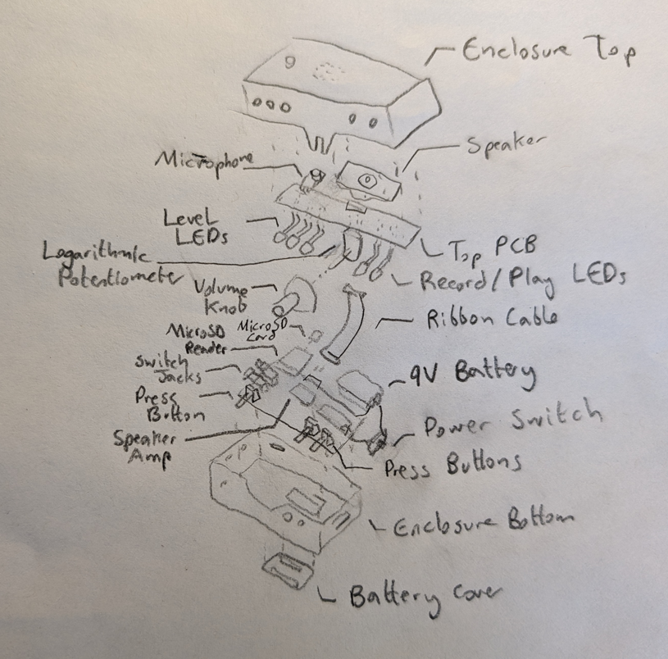

**Updated Components**

|  |  |  |  |
| --- | --- | --- | --- |
| **Component** | **Quantity** | **Price** | **Link** |
| Jack | 2 | 1.98 (2.13) | [Link](https://www.digikey.ca/en/products/detail/cui-devices/SJ1-3535NG/738699?s=N4IgTCBcDaIMIAUCMBaAzAVkwOQOIuwBEQBdAXyA) |
| Button | 3 | 0.82 (0.76) | [Link](https://www.digikey.ca/en/products/detail/w%C3%BCrth-elektronik/431256058736/5209065?s=N4IgTCBcDaICwGYCMYCsA2ADKgHAdgXQFoA5AERAF0BfIA) |
| Power Switch | 1 | 0.89 (0.93) | [Link](https://www.digikey.ca/en/products/detail/c-k/OS102011MA1QN1/1981430) |
| Potentiometer | 1 | 2.64 (2.13) | [Link](https://www.digikey.ca/en/products/detail/cui-devices/PTN16-A10125K1A2/20380750) |
| 10 wire ribbon cable | 1 | 1.82 () | [Link](https://www.digikey.ca/en/products/detail/assmann-wsw-components/H3DDS-1006G/1218627) |
| 10 wire ribbon cable connector | 2 | 0.86 () | [Link](https://www.digikey.ca/en/products/detail/amphenol-cs-fci/86130101014345E1LF/7592367?s=N4IgTCBcDaIBwDYCMBmADEjGAsLsFYBRJAGQDEQBdAXyA) |

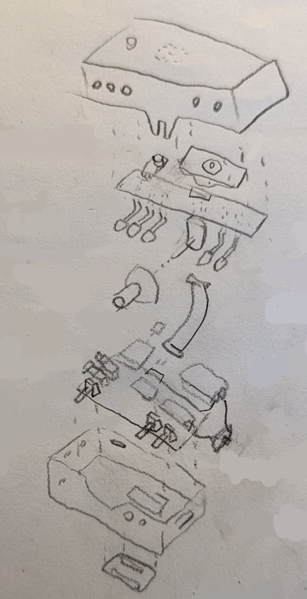

## Updated Enclosure Design

Since the PCBs are so much smaller than the original enclosure, the fact that the buttons and jacks are PCB mount means that the enclosure must be redesigned around the PCBs. After the first draft of the PCBs were made, all the components were imported into Fusion and arranged in the most compact manner possible. From here, the basic enclosure was modeled around the components. At this point, several changes to the PCBs were required to allow clearance for the screws holding the enclosure together, and to change the position of the microphone to make the enclosure more symmetric.

The design of the buttons and the battery holder was also overhauled from the initial version. The buttons on the initial enclosure were press fit onto the actual buttons, with a bit of hot glue holding them in place. This was fragile and prone to being knocked off, so the updated enclosure includes buttons that are inserted from the inside, and held in place by the PCB buttons after the PCB is inserted.

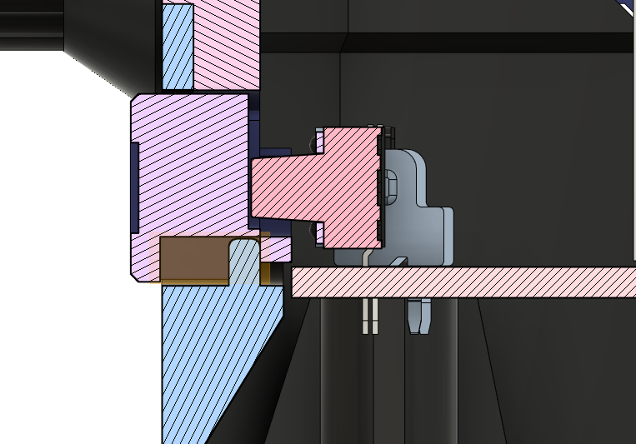 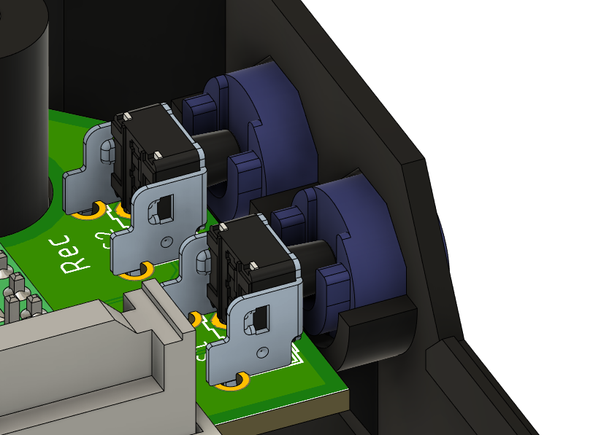

The battery holder was also redesigned, both to securely hold the battery so it can’t be shaken loose internally, and to allow the battery holder to more easily be removed from the enclosure with minimal force.

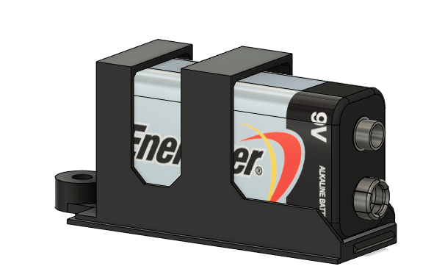

The LEDs used on the top circuit board need to be bent 90 degrees at a specific point to fit into the corresponding holes in the enclosure. In the past, 3D printed jigs have been used to bend components at a fixed point to eliminate the need to measure and guess. 3D printed spacers have also been used in the past to offset LEDs from the PCB. These two concepts were combined in this project to create a tiered spacer that allows the LEDs to be soldered to the board at the correct height, then bent using the spacer as a jig to get the correct angle and distances.

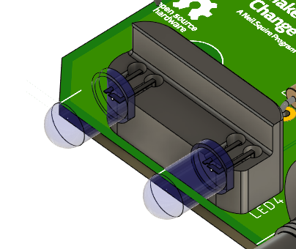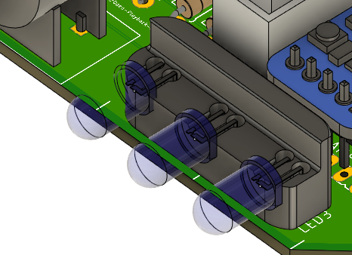

## Initial PCB Design

The first PCB design designed alongside the new enclosure, and the PCBs and parts were ordered. Once everything arrived, the device was assembled using the previous code with no changes. The basic functionality of the device worked well, but there were three noticed issues that required a PCB rework.

The primary issue noticed was with the headers that connected the two halves of the device together. The actual headers were much larger than expected, and without a 3D model to incorporate them into the CAD, it went unnoticed that the headers would interfere with each other and the microcontroller. To fix this, in the next iteration of the PCBs the location of the header on the top PCB has been moved. Now that the header parts have arrived, they have been modeled and it has been verified that they will not interfere when assembled.

The second issue that was noticed was that the LED for level 3 was lighting when the device was in level 1, and vice versa. While this was an easy fix in software, since changes were already being made to the PCBs it was decided to swap the two LEDs to keep the software the same between the protoboard and PCB designs.

Finally, it was noticed that when a switch was connected to the Play jack, the level would also activate whenever the switch was pressed. This behavior stopped when a multimeter was used to measure the voltage on the input pin or when a 10k resistor was connected between the input pin and the 5V pin. This behavior seems like a floating input pin, but internal pullups have been enabled on all the microcontroller inputs. To solve this, optional pullup resistors were added to each of the microcontroller inputs to allow the maker to add resistors if the input is floating.

## Final V2.0 Design

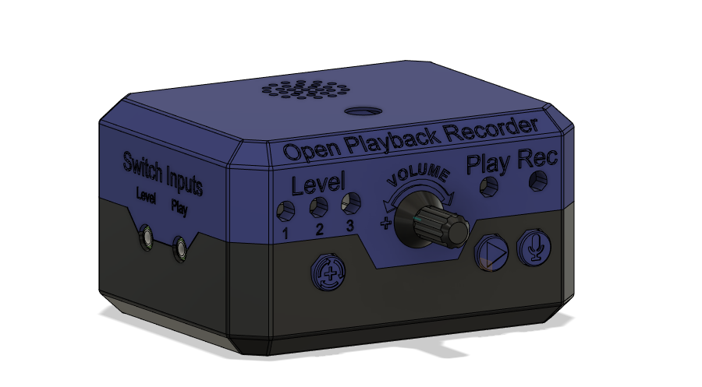

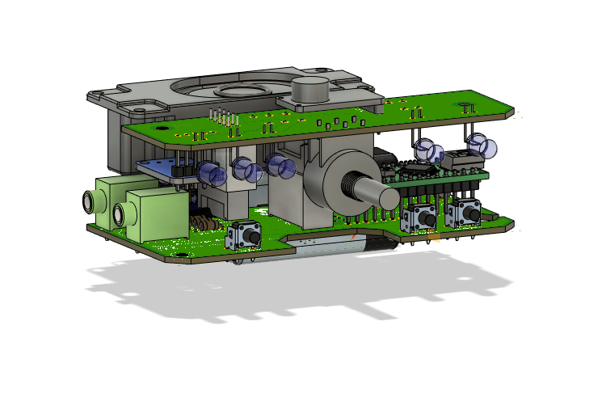

## V2.0 Testing and Validation

### V2.0 Internal Testing

Test pull-up resistors and input ghosting

#### Input Ghosting

When an assistive switch is connected to the play jack and it is pressed, the level switch will sometimes also activate, with nothing connected to the level jack and the level button not being pressed. There is already an internal pullup resistor on both the play and level input pins. On the first prototype PCB, this was eliminated by soldering a 10k resistor between the level pin and the 5V pin on the microcontroller.

On the second iteration of the board, a footprint was added for the pullup resistors, however this made them less effective, with the ghost input happening roughly half the time.

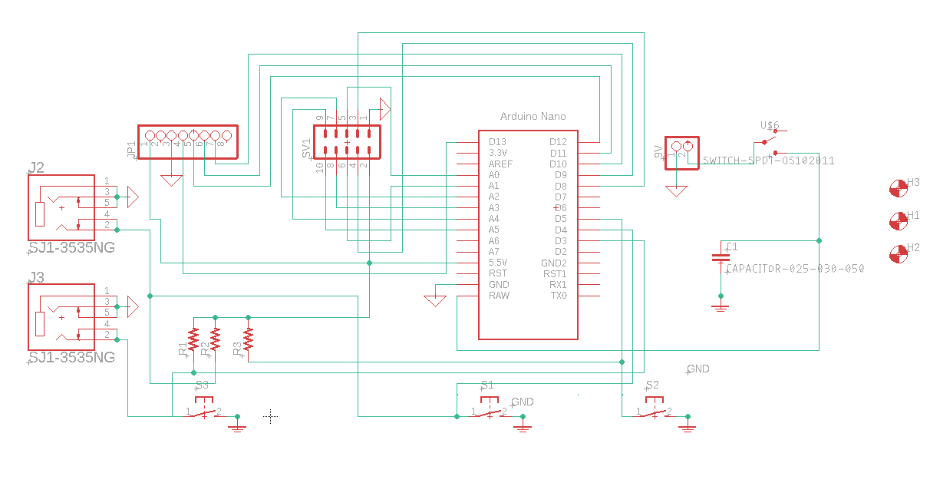

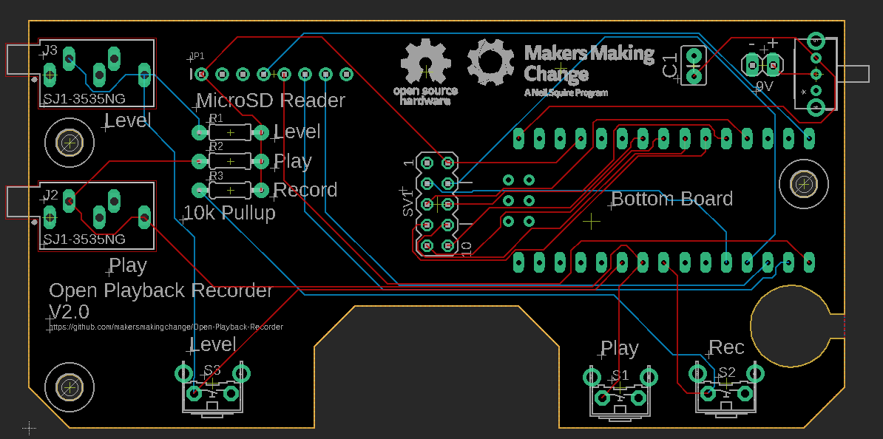

After reviewing the software for the OPR, it was found that the fact that the level switch input was an interrupt was causing issues. Since interrupts cannot trigger within an Interrupt Service Routine(ISR), things such as timers and delays cannot be used within the ISR for the level change. This makes it difficult to debounce the level switch in software since any debouncing after the ISR would simply be interrupted when the ISR is triggered again by the bouncing. Since the level change is only needed in the main loop and is not used while playing or recording messages, the interrupt was removed and an if statement added to the main loop to poll the state of the level pin. This change solved both the input ghosting and the switch bouncing issue with no changes needed on the PCB.

### V2.0 User Testing

Test if having the microcontroller and microSD card accessible is a useful addition

Test to make sure that no functionality was lost

### V2.0 Build Testing

Test maker guide to verify the instructions are clear, easy to understand, and have no errors.

## OFIs for V2.1

* Add sliding covers for microcontroller, power switch, and the microSD card
* Get OSHWA certification
* Possible to lose the microSD card in the enclosure when removing it